Project Report:
Customer Churn Analysis Using Python (Data Analysis)
Prepared By: Sukanya Das
Date: 27/01/2026

Abstract:

This project performs customer churn analysis using Python libraries (Pandas, NumPy, Matplotlib, Seaborn). The goal is to explore customer behavior, identify churn patterns, and visualize insights that can help businesses improve retention strategies.

Introduction:

What is Churn?

Churn, or customer attrition, is the rate at which customers stop doing business with an entity or discontinue their subscriptions over a specific period. It is a vital metric for tracking customer retention, satisfaction, and overall business health, particularly in subscription-based (SaaS) models.

Why churn analysis matters for businesses?
Churn analysis is essential because retaining existing customers is significantly cheaper than acquiring new ones, directly impacting profitability and long-term growth. It helps businesses identify why customers leave—due to poor experience, pricing, or competition—allowing them to improve products, enhance customer service, and proactively intervene to stop churn before it happens.

Key reasons why churn analysis matters for businesses include:
• Cost Efficiency (CAC Reduction): Acquiring new customers can cost 5 to 7 times more than retaining current ones. Analyzing churn helps reduce these high acquisition costs by improving retention strategies.
• Revenue Stability: A lower churn rate leads to more consistent, predictable revenue streams and higher customer lifetime value.
• Actionable Insights for Improvement: It provides direct feedback on product defects, poor user experience, or service issues, allowing companies to fix problems and better align with customer needs.
• Competitve Advantage: Understanding why customers switch to competitors allows businesses to refine their market positioning and improve their value proposition.
• Proactive Reaction: By analyzing behavioral patterns (e.g., decreased engagement), businesses can identify at-risk customers and intervene before they leave.

Dataset Description:

• Source of dataset:
Publicly Available Open – Source Data Repository.

• Number of rows and columns:
7043 rows × 21 columns

•Key Features Description:
The dataset consists of various attributes categorized into three main segments:
Demographics: Includes basic customer profile information such as Gender, Senior Citizen status (0/1), and whether they have Partners or Dependents.
Service Subscription Details: This section covers the types of services each customer is using, including Phone Service, Multiple Lines, Internet Service (DSL/Fiber optic), Online Security, Device Protection, Tech Support, and Streaming TV/Movies.
Billing and Account Information: Contains financial and contract data like Tenure (months with the company), Contract type (Month-to-month/One year/Two year), Paperless Billing, Payment Method, Monthly Charges, and Total Charges.
Target Label (Churn): The primary variable indicating whether the customer left the service (Yes) or stayed (No).

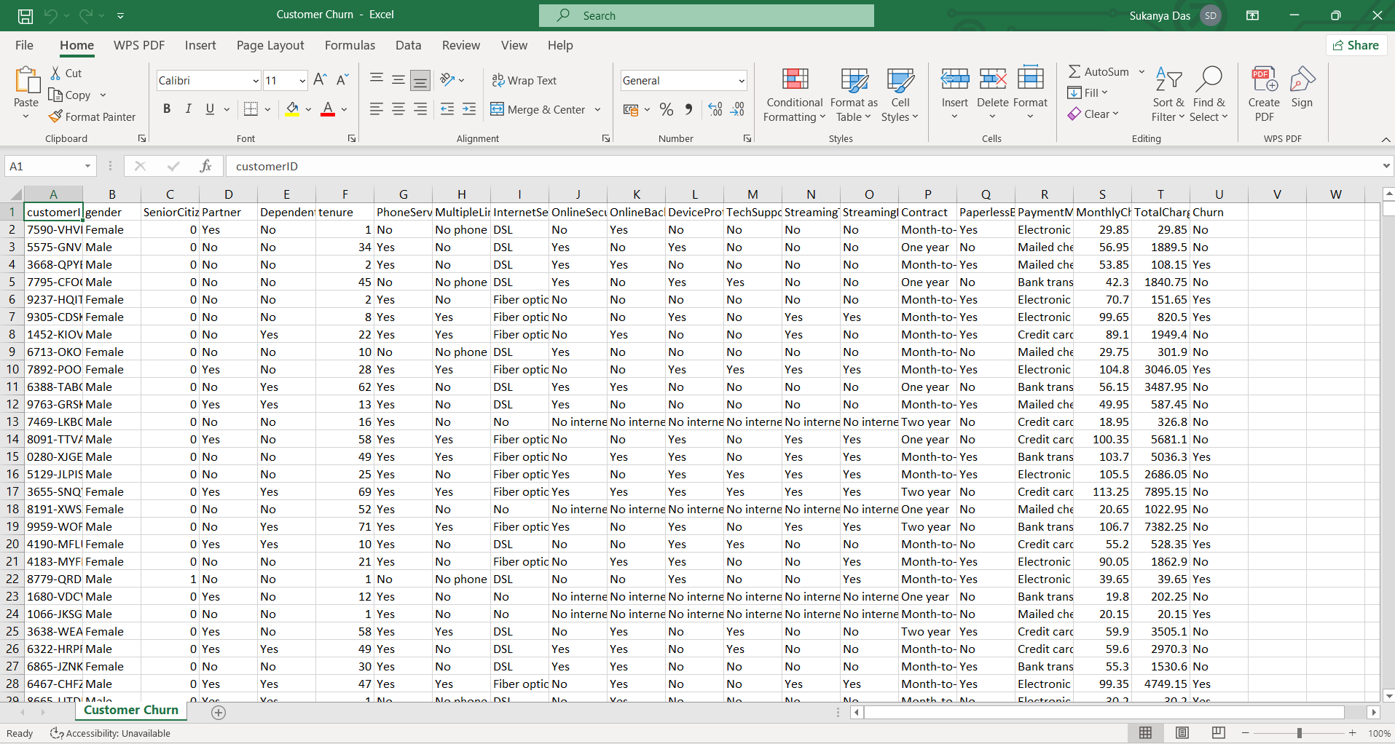
Data Preview — Customer Churn Dataset showing initial records and attributes
Methodology:
Data Preprocessing:
- Handling missing values.
- Encoding categorical variables.
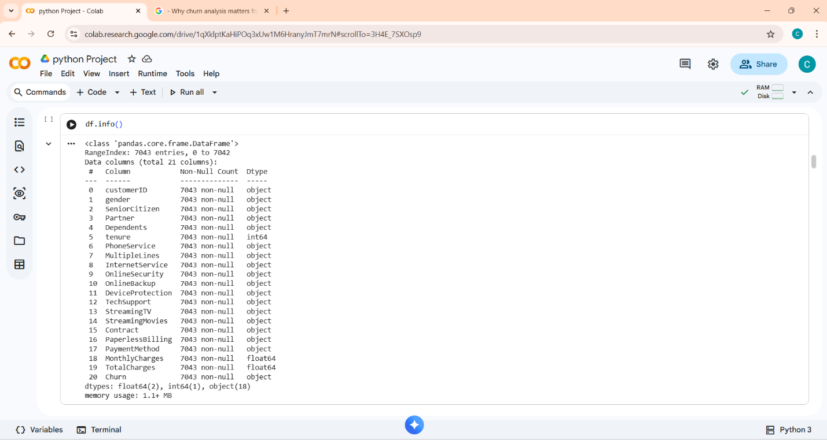
- Basic statistics (mean, median, mode).

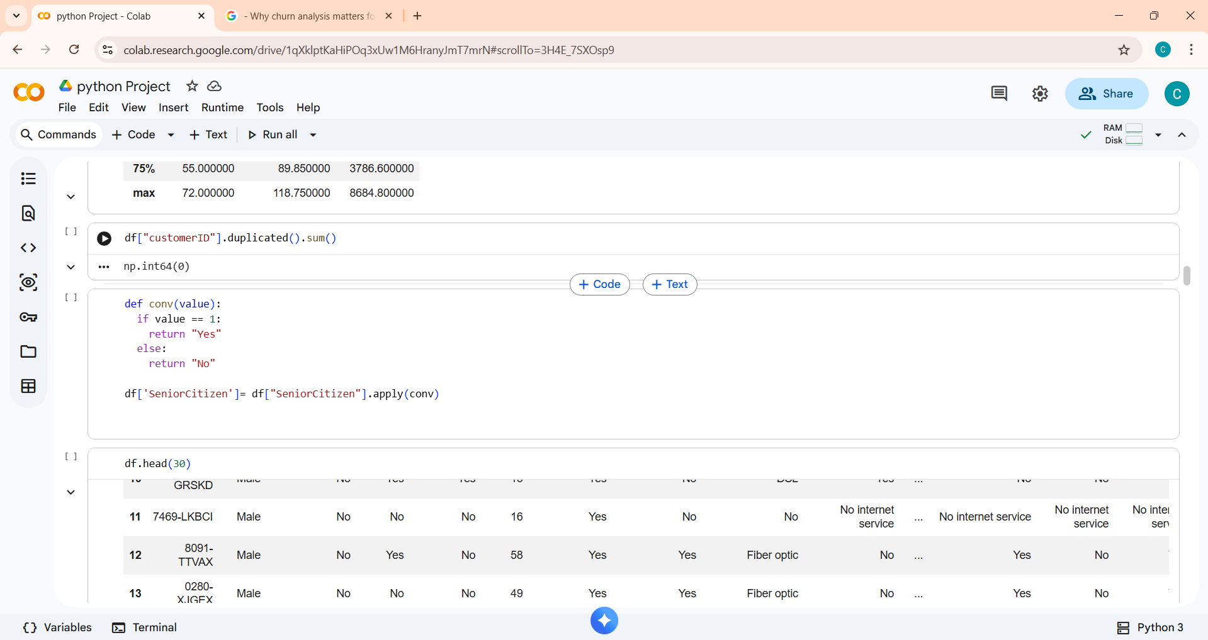
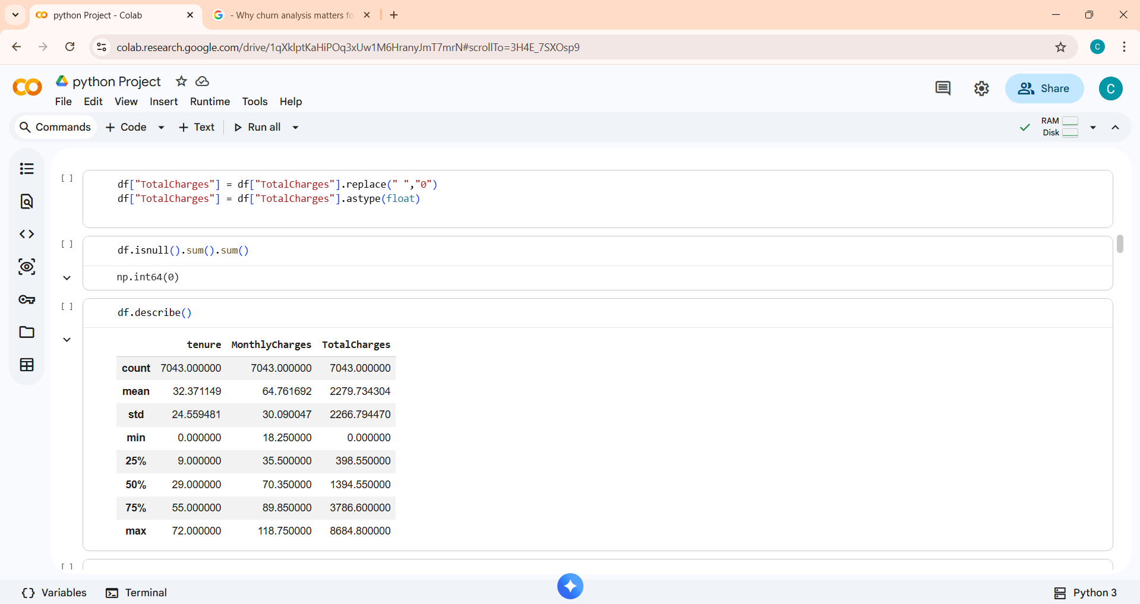

Data cleaning code or Summary statistics table.
Exploratory Data Analysis (EDA):
• Distribution of churn vs non-churn customers.
•Relationship between churn and contract type.
•Monthly charges vs churn.
•Tenure vs churn.

These are the All Curves:
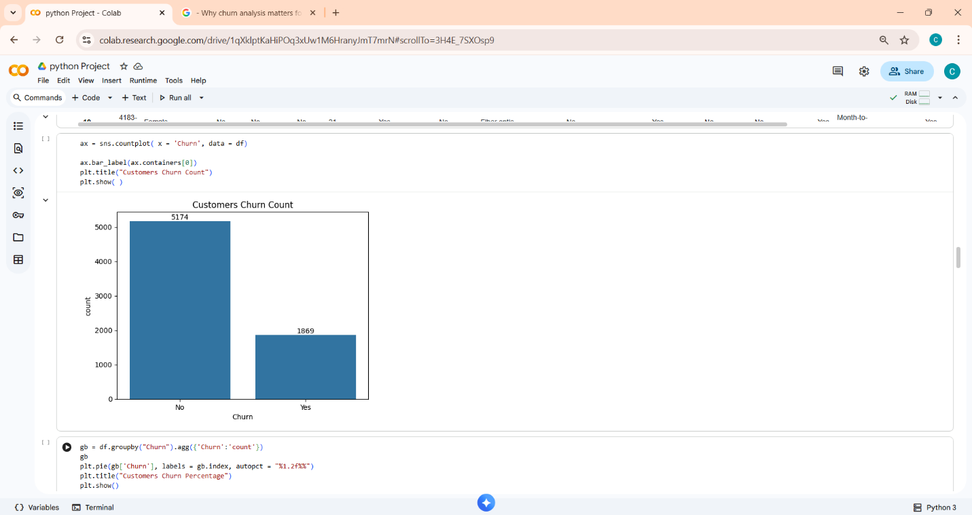

Curve 01:

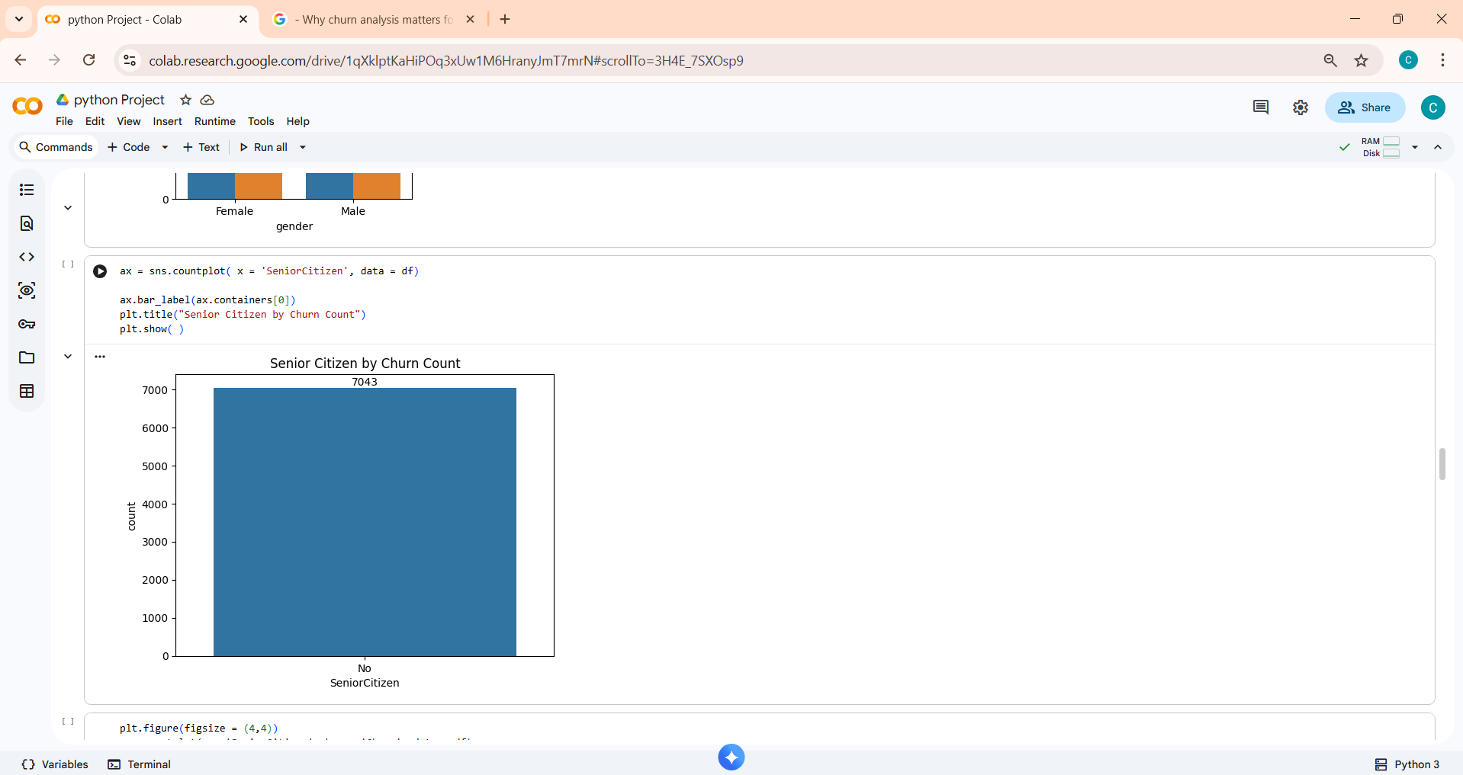
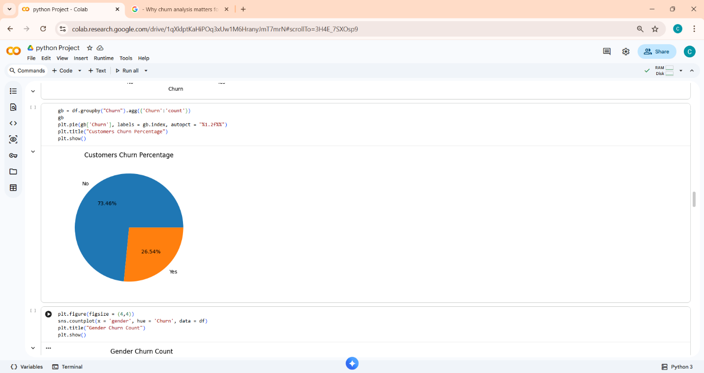
Curve: 02
Curve: 03


Curve: 04
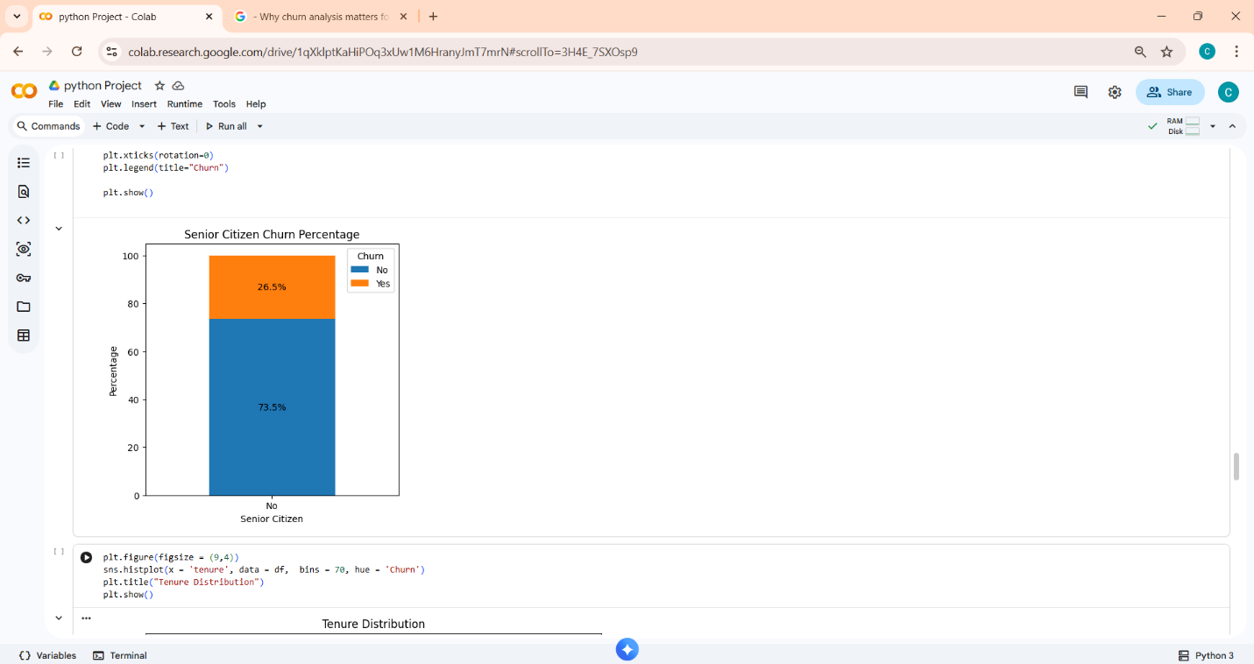
Curve: 05

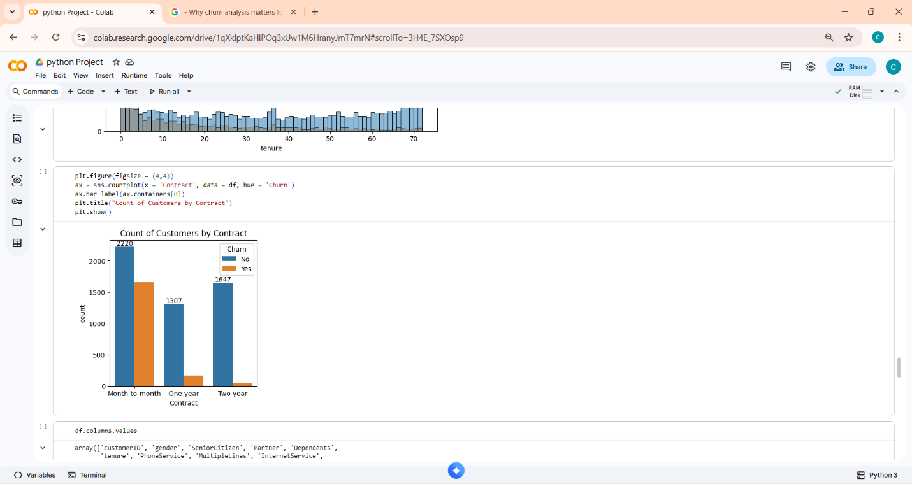
Curve: 06
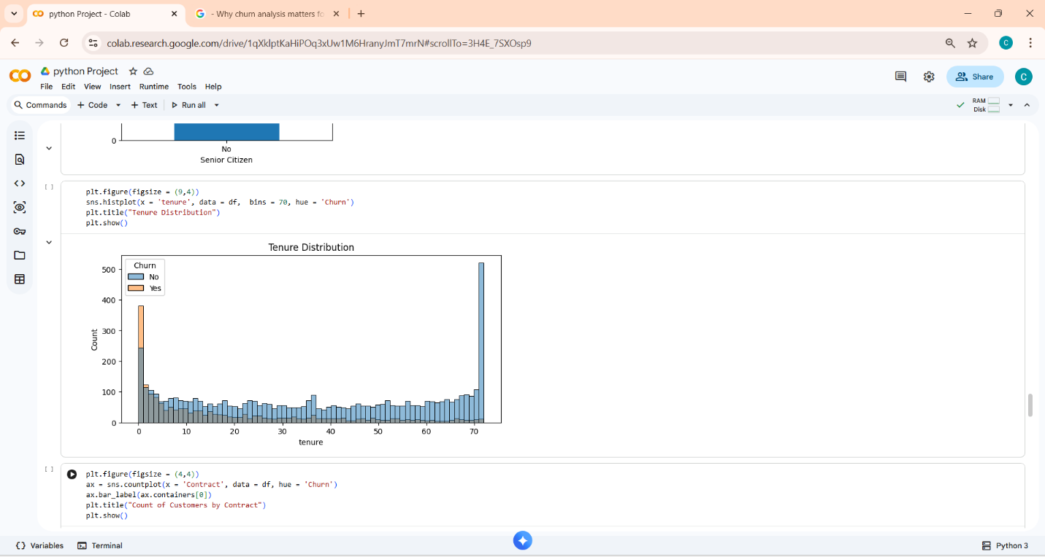
Curve: 07


Curve: 08

Results & Insights:
- Customers with month-to-month contracts churn more.
- Higher monthly charges → higher churn.
- Senior citizens churn more than younger customers.
- Customers with longer tenure churn less.

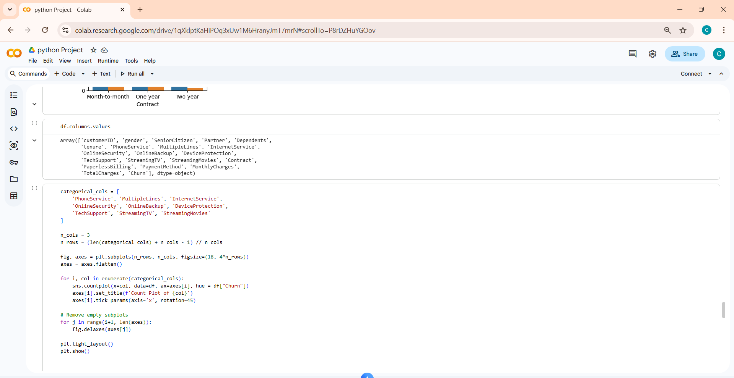

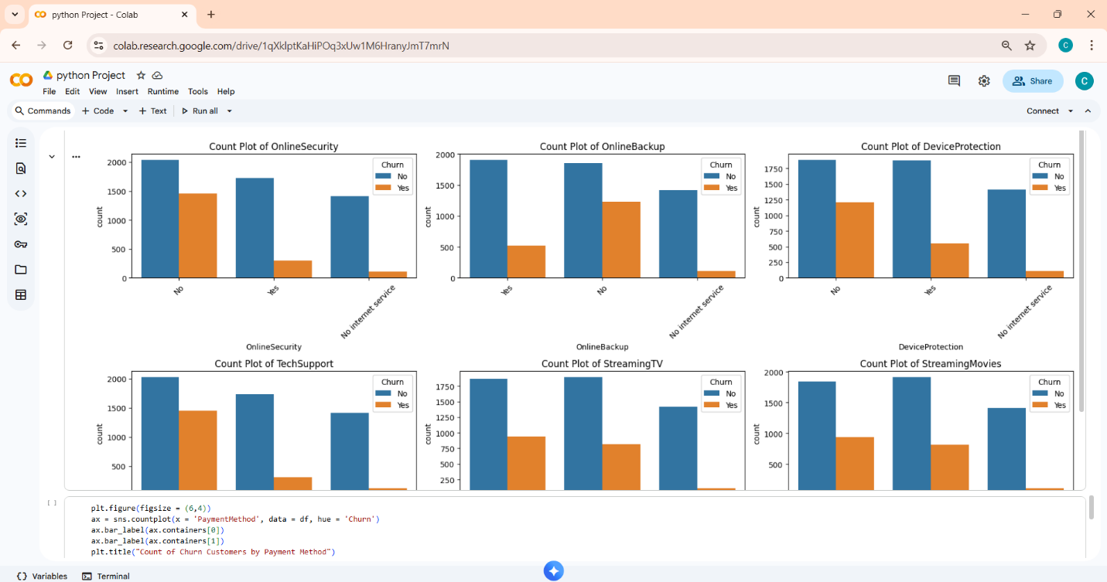
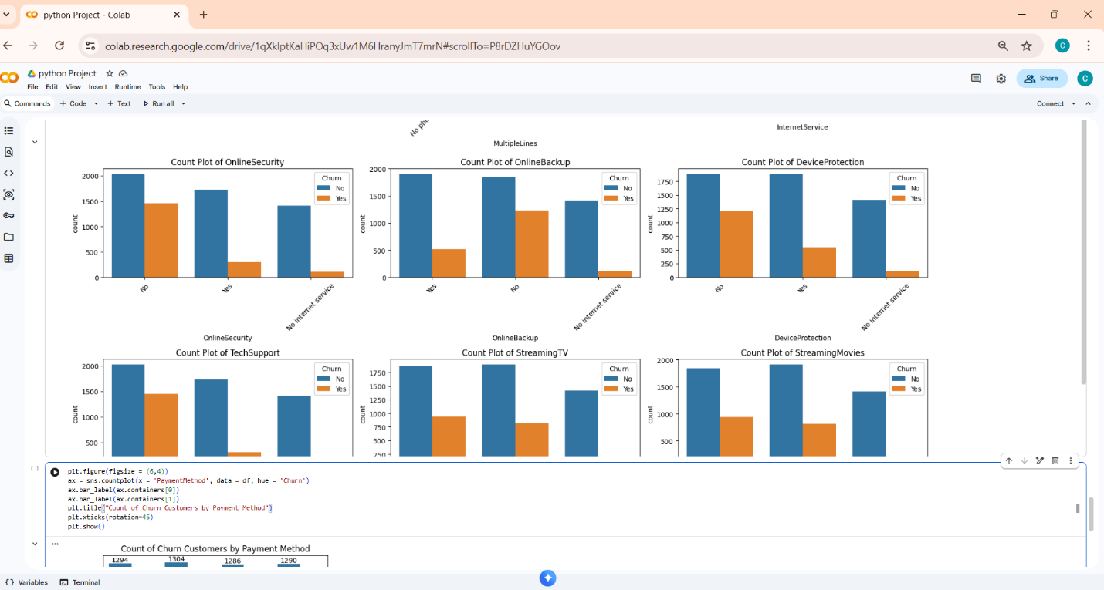

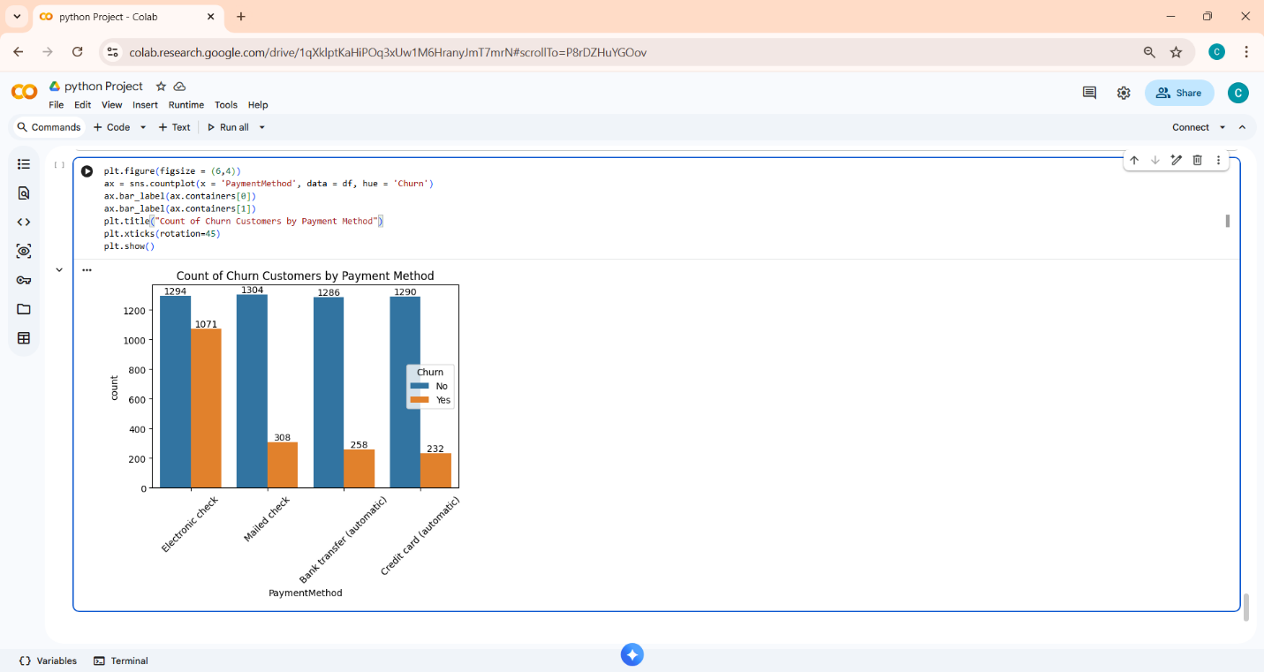

Metrics Section :
1. Churn Rate
- Formula:
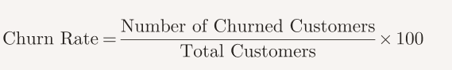
- Example: If 1,869 out of 7,043 customers churned → Churn Rate ≈ 26.5%.

2. Tenure Statistics
- Average tenure of churned customers vs retained customers.
- Example: Churned customers average ~18 months, retained customers average ~36 months.
3. Monthly Charges
- Mean monthly charges for churned vs retained customers.
- Example: Churned customers average $74/month, retained customers average $61/month.
4. Contract Type Distribution
- Percentage of churn across contract types:
- Month-to-Month: ~43% churn
- One-Year: ~11% churn
- Two-Year: ~3% churn
5. Service Usage
- Churn rate among customers with multiple services (Internet, Streaming, Phone).
- Example: Internet service customers churn more than phone-only customers.

Recommendations :
- Contract Type: Encourage long-term contracts, since month-to-month customers churn more.

- High Monthly Charges: Offer discounts or personalized plans to customers with high charges.

- Senior Citizens: Provide better support and engagement programs for older customers.

- Tenure: Reward loyal customers with tenure-based benefits to reduce churn.
.

Conclusion:
Python-based data analysis helped uncover churn patterns and provided actionable insights. Businesses can use these findings to design retention strategies and reduce churn.
Future Work:
- Extend analysis with machine learning models.
- Add external data sources (customer feedback, surveys).
- Build interactive dashboards (Power BI, Tableau, or Python Dash).

References:
Python libraries: Pandas, NumPy, Matplotlib, Seaborn.

THANK YOU

